Mr. Visca – AP Calculus AB

Unit 5: The definite integral Review Notes

**RAM: Rectangular Approximation Methods**

* LRAM - ___________ rectangular approx. method;
* RRAM - ___________ rectangular approx. method;
* MRAM - ___________ rectangular approx. method;

More intervals, the more accurate!

Approximate the area under the curve of the function y = 2x – x2 using LRAM on the interval [0,2] using 4 equal rectangles. Sketch the function on the given interval.

**The Definite Integral**

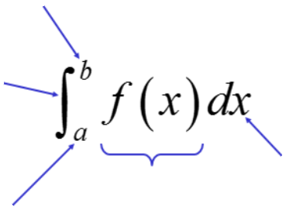

Opposite process of power derivative rule:

1st: ____________________________

2nd: ___________________________

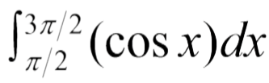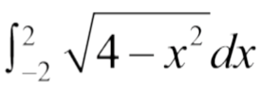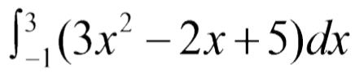

[hint: geometry can be helpful]

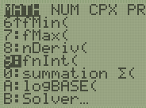Calculator: math, 9 🡪 fnInt()

**Mean Value Theorem for Integrals**

“Average Value” for area under the curve:

Find the average value of the function on the interval, using antiderivatives to compute the integral of the following:



y = 3x2 on the interval [-1,2]

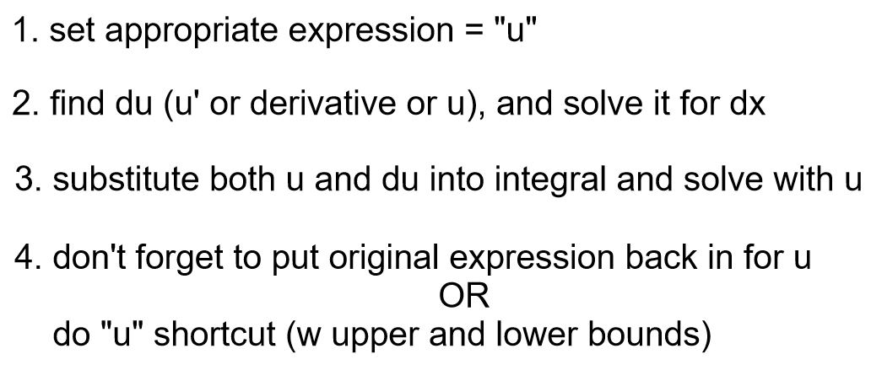**U SUB Integration**

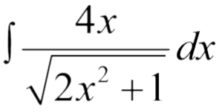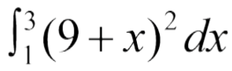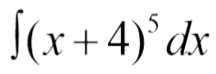

**Fundamental Theorem of Calculus**

$$\frac{dF}{dx}=$$

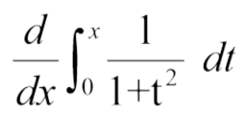

=

Upper Bound is constant?

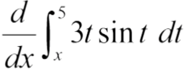

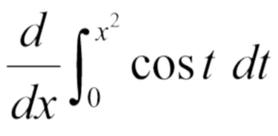Derivative variable and upper limit do not match?

What if there is no constant?

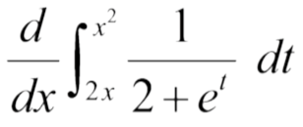

Part 2 of Fundamental Theorem of Calculus (aka Integral Evaluation Theorem)

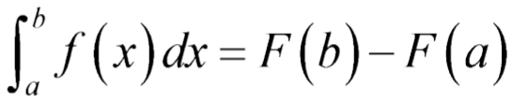

**Trapezoid Rule:**

$$T=$$

**Simpsons Rule:**



$$S=$$

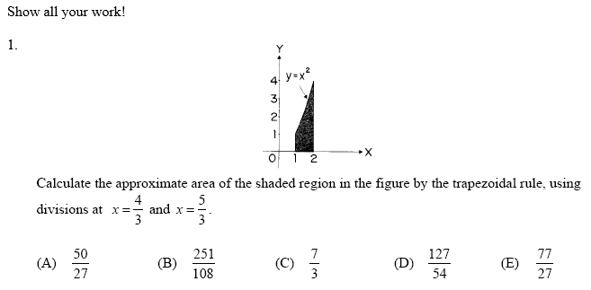

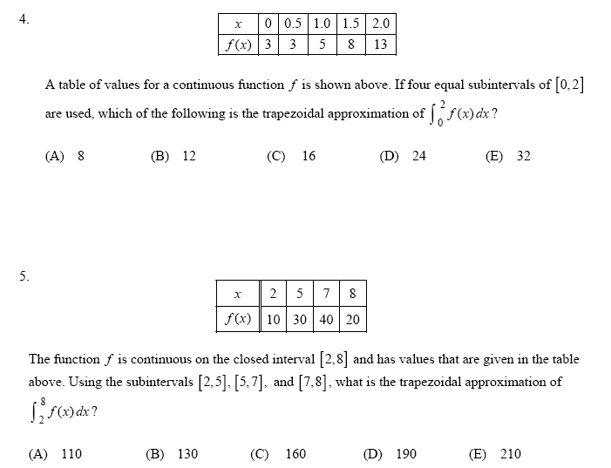

**Unit 5 Review Practice Problems**

Show all your work! Scientific calculator allowed. Graphing calculator not allowed.

For Review use Chapter 5 Review in Book as well as 2005AB FRQ 4 ands the following:

1. 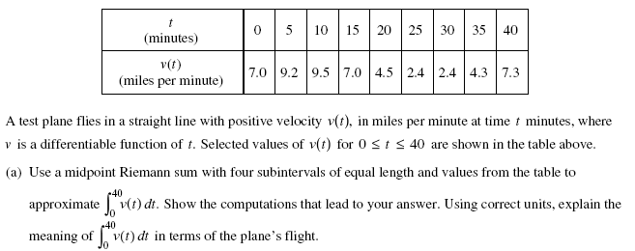

2.

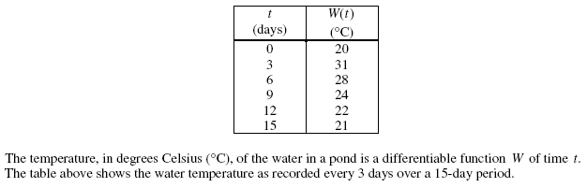



3. 4.

5. The chart below shows the time and distance a rabbit travels from t = 0 seconds to t = 5 seconds. Determine the total distance the rabbit travels in that time.

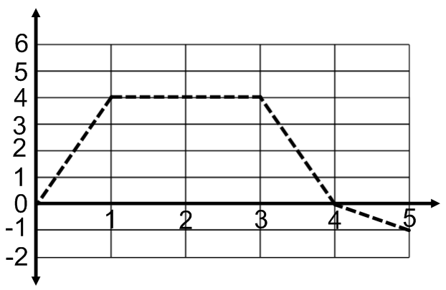

6. If , find F’(4). 7. Find the average value of -sin x from [-π, 2π]

